

**KULLIYYAH OF INFORMATION AND COMMUNICATION TECHNOLOGY**

**DEPARTMENT OF INFORMATION SYSTEMS**

**INFO 1103 – Database Systems**

**Semester 1 2017/2018**

**Preliminary Report**

IIUM Sports Facilities Booking

**Section : [2]**

**Team Name:** IIUM Runner

**Group Members**

Ahmad Zaidan bin Adnan 1718733

Luqman bin Mohammad 1714425

Mohd. Syafiq Asyraf bin Samsudin 1715447

Mohamad Zaki bin Jaafar 1719207

Supervised by

Dr. Lili Marziana Abdullah

**1.0 Introduction**

Our team is working on an important project involving the management of IIUM sports facilities. The proposed system introduced is called IIUM Sports Facilities Booking. For several years, the booking procedure of sports facilities in IIUM is handled manually by staffs and administrators. However, there are further consequences that might occur in the future such as slow management and ambiguity in preserving records. Therefore, this new online booking system will replace the manual booking system with an integrated computerised system that will speed up the process, improve customer service and reduce operational cost. This project is estimated to cost about RM 200, 000 and the duration of the system to be completed is at least 1 year.

The project team is led by our Project Manager Br. Mohd. Syafiq Asyraf bin Samsudin from Innovated Data Sdn Bhd and the team members are consist of system analyst, analyst programmer and database administrator. Innovated Data Sdn Bhd has been one of the leading companies in system development project for the past five years.

**1.1 Project Team Organization**

**1.2 Business Transactions**

1. Register Customer
2. Book Venue
3. Book Equipment
4. Check Venue Availability
5. Check Equipment Availability
6. Process Venue Booking Fee
7. Process Equipment Booking Fee
8. Update Venue Status
9. Update Equipment Status
10. Print Sales Report
11. Print Booking Receipt

**1.3 Screen Design**

1. Customer Registration Screen

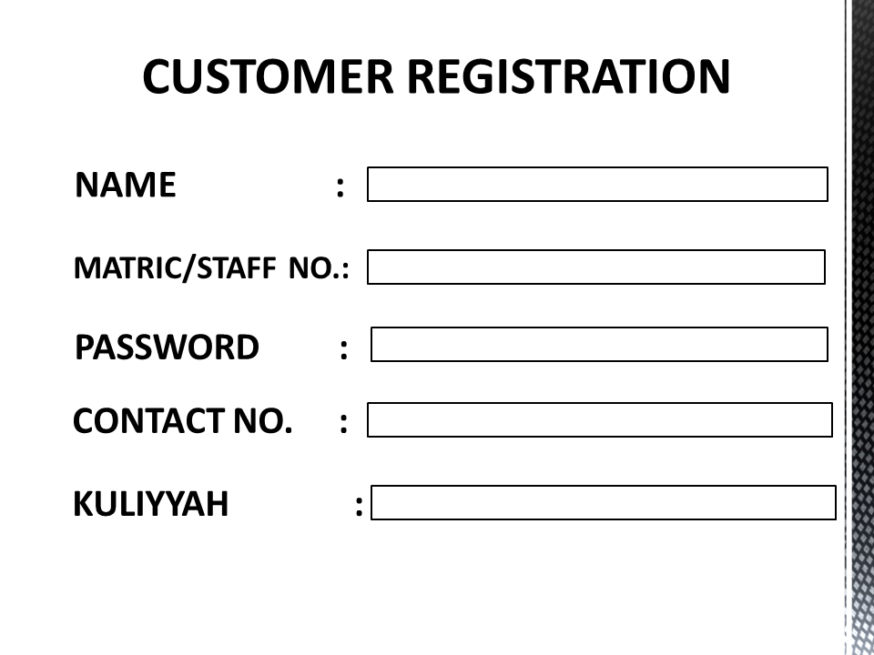

1. Customer Login Screen

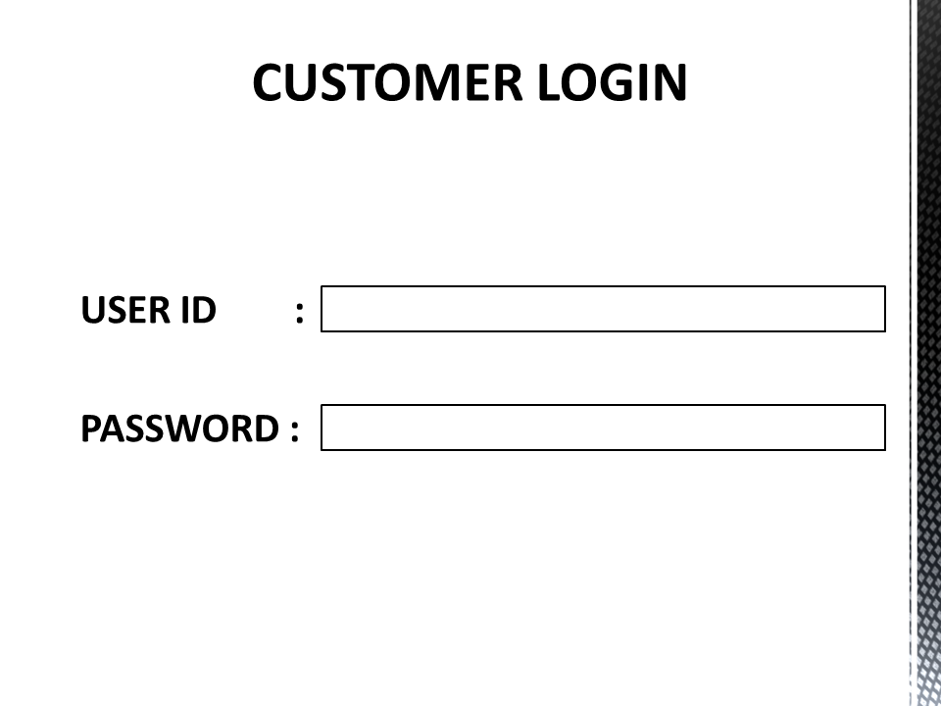

1. Venue Booking Screen

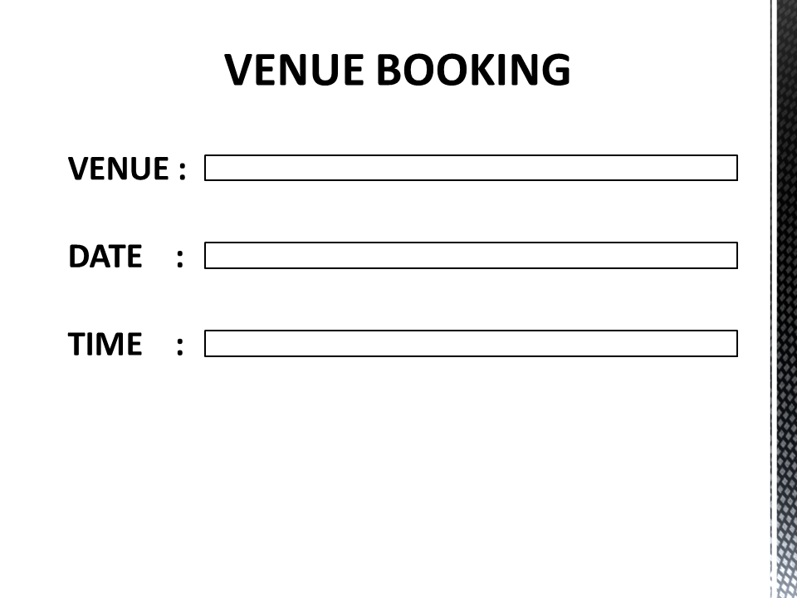

1. Equipment Booking Screen

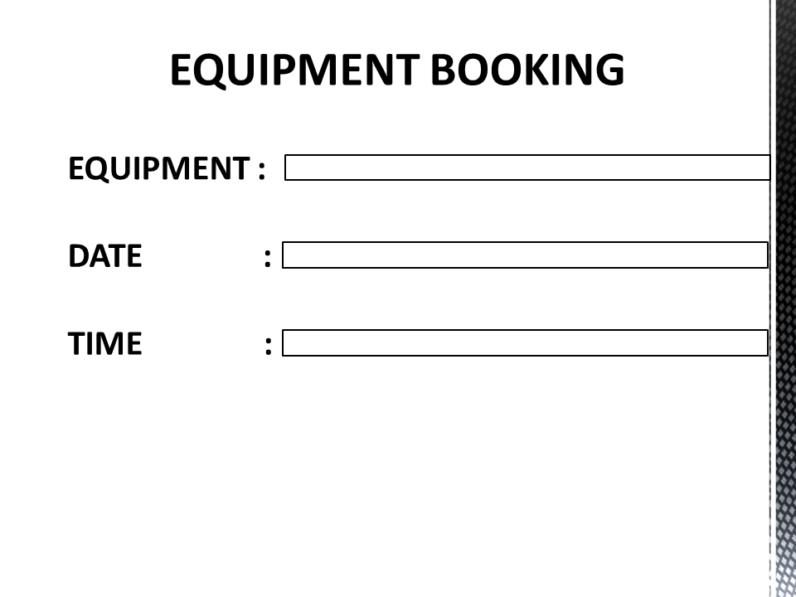

**1.4 Document / Report Design**

Booking receipt:

**BOOKING RECEIPT**

Signature:

Total Amount of Booking Fees:

Booked Facilities:

1.

2.

Booked Equipment:

1.

2.

Customer ID:

Receipt No. :

Date:

**2.0 CONCEPTUAL DATABASE DESIGN**

**Enhanced Entity-Relationship Model**

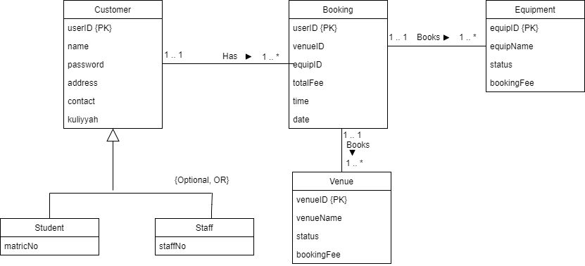

Bdate

Rdate

Btime

Rtime

{Mandatory, OR}

**3.0 LOGICAL DATABASE DESIGN**

Customer ( userID, name, matricNo, staffNo, password, contact, kuliyyah)

Primary Key – userID

Booking ( userID, venueID, equipID, Btime, Rtime, date)

Primary Key - userID

Foreign Key – userID reference Customer(userID)

Foreign Key – venueID reference Venue(venueID)

Foreign Key – equipID reference Equipment(equipID)

Venue ( venueID, venueName status, bookingFee)

Primary Key – venueID

Foreign Key – venueID reference Booking(venueID)

Equipment ( equipID, equipName, status, bookingFee)

Primary Key – equipID

Foreign Key – equipID reference Booking(equipID)

**4.0 PHYSICAL DATABASE DESIGN**

CREATE TABLE Customer

( userID Varchar(8) NOT NULL,

name Char(15) NOT NULL,

matricNo Char(8),

staffNo Char(7),

password Varchar(8) NOT NULL,

contact Char(11) NOT NULL,

kuliyyah Char(8) NOT NULL,

CONSTRAINT Customer_userID_pk PRIMARY KEY (userID));

CREATE TABLE Booking

(userID Varchar(7) NOT NULL,

venueID Varchar(10),

equipID Varchar(10),

bTime Varchar(8) NOT NULL,

bDate Varchar(10) NOT NULL,

rTime Varchar(8),

rDate Varchar(10),

CONSTRAINT Booking_userID_pk PRIMARY KEY (userID),

CONSTRAINT Booking_venueID_fk FOREIGN KEY (venueID) REFERENCES Venue (venueID) ,

CONSTRAINT Booking_equipID_fk FOREIGN KEY (equipID) REFERENCES Equipment (equipID));

CREATE TABLE Venue

(venueID Varchar(10) NOT NULL,

venueName Varchar(25) NOT NULL,

status Char(6) NOT NULL,

bookingFee Integer NOT NULL,

CONSTRAINT Venue_venueID_pk PRIMARY KEY (venueID));

CREATE TABLE Equipment

(equipID Varchar(10) NOT NULL,

equipName Varchar(20) NOT NULL,

status Char(6) NOT NULL,

bookingFee Integer NOT NULL,

CONSTRAINT Equipment_equipID_pk PRIMARY KEY (equipID));

**5.0 SAMPLES QUERIES**

**5.1 Basic queries**

Q1.1 Insert record for 1 customer who is a staff named ‘Said Ali’

INSERT INTO Customer (userID, name, staffNo, password, contact, kuliyyah) Values ('stf01', 'Said Ali', '4302', '12345', '0198765934', 'ECONS');

Q1.2 Change kuliyyah of customer with user ID ‘std04’ from ‘ECONS’ to ‘KICT’

UPDATE Customer SET kuliyyah=’KICT’ WHERE userID=’std04’;

Q1.3 List all venues that are available

SELECT*FROM Venue WHERE status = ‘Y’;

Q1.4 List equipment name and booking fee of all equipment

SELECT equipName, bookingFee FROM Equipment;

Q1.5 List all distinct kuliyyah

SELECT DISTINCT kuliyyah FROM Customer;

**5.2 Operational Queries**

Q2.1 Calculate the total fees of all equipments

SELECT SUM( bookingFee) AS mySum FROM Equipment;

Q2.2 Calculate the total number of user which are students

SELECT COUNT(UserID)AS studentCount FROM Customer WHERE UserID LIKE ’%std%’;

Q2.3 List all the details of users which are staffs from the Kuliyyah ‘AIKOL’

SELECT * FROM Customer WHERE UserID LIKE ’%stf%’ AND Kuliyyah = ’AIKOL’;

Q2.4 List the booking details of volleyball court and futsal court A in descending order based on venueID

SELECT * FROM Booking WHERE VenueID = ’vbc01’ or VenueID = ’fst01’ ORDER BY VenueID DESC;

Q2.5 Select the minimun, maximum and the average booking fees of the venue;

SELECT MIN (BookingFee) AS minFee, MAX(BookingFee) AS maxFee, AVG(BookingFee) AS avgFee FROM Venue;

**5.3 Strategic queries**

Q3.1 List the number of students and staff from each kuliyyah grouped by their user ID.

SELECT COUNT(userID)AS myCount, kuliyyah FROM Customer GROUP BY kuliyyah;

Q3.2 List all venues that have been booked on 1/8/2017

SELECT * FROM Venue WHERE venueID IN (SELECT venueID FROM Booking WHERE bDate = ’2017-08-01’);

Q3.3 List all customers who are staff that have booked a venue or equipment

SELECT * FROM Customer WHERE userID IN (SELECT userID FROM Booking WHERE userID LIKE ‘%stf%’);

Q3.4 List all customers that have booked an equipment or venue

SELECT s.userID, d.staffNo, d.matricNo FROM Booking s, Customer d WHERE s.userID=d.userID;

Q3.5 Display venueID, venueName and booking fee that have a fee less than the average total fees of all venues.

SELECT venueID, venueName, bookingFee FROM Venue WHERE bookingFee < (SELECT AVG(bookingFee) from Venue);

**5.4 User Views**

Q4.1 Create a view for customer with userID std02 checking on their booking.

CREATE VIEW BookingofUser

AS SELECT *

FROM Booking

WHERE userID = ‘std02’;

Q4.2 Create a view for Middle Management (Operational Manager).

CREATE VIEW MidManager1

AS SELECT userID, name, staffNo, matricNo, contact, kuliyyah

FROM Customer;

CREATE VIEW MidManager2

AS SELECT *

FROM Booking;

Q4.3 Create a view for Top Management.

CREATE VIEW TopManager1

AS SELECT *

FROM Customer;

CREATE VIEW TopManager2

AS SELECT *

FROM Booking;

CREATE VIEW TopManager3

AS SELECT *

FROM Venue;

CREATE VIEW TopManager4

AS SELECT *

FROM Equipment;

**6.0 RECORD LISTING**

**Student Records**

|  |  |  |  |  |
| --- | --- | --- | --- | --- |
| **Name** | **Matric No** | **Password** | **Contact** | **Kuliyyah** |
| Zaidan Adnan | 1718733 | 12345 | 0128782934 | KICT |
| Ahmad Syauqi | 1216560 | 12345 | 0109826728 | AIKOL |
| Omar Ali | 1520991 | 12345 | 0139824092 | ENGIN |
| M.Saifuddin | 1410298 | 12345 | 0190283934 | ECONS |
| Haziq Haikal | 1623637 | 12345 | 0111789278 | KIRKHS |
| Siti Fatimah | 1617929 | 12345 | 0112628392 | KLM |

**Staff Records**

|  |  |  |  |  |
| --- | --- | --- | --- | --- |
| **Name** | **Staff No** | **Password** | **Contact** | **Kuliyyah** |
| Said Ali | 4302 | 12345 | 0198765934 | ECONS |
| Nur Rahmah | 2091 | 12345 | 0129825367 | AIKOL |
| Hamzah Sidiq | 3905 | 12345 | 0189804991 | KOED |
| Mohd Syarif | 4892 | 12345 | 0120289304 | KLM |
| Ahmad Saiful | 4399 | 12345 | 0140788282 | KAED |

**Booking Records**

|  |  |  |  |  |  |  |
| --- | --- | --- | --- | --- | --- | --- |
| **UserID** | **VenueID** | **EquipID** | **bTime** | **bDate** | **rTime** | **rDAte** |
| std02 | msc01 |  | 8:00:00 AM | 2017-08-01 | 6:00:00 PM | 2017-08-02 |
| std05 | fst01 |  | 9:00:00 AM | 2017-05-05 |  |  |
| std06 |  | vball01 | 10:00:00 AM | 2017-03-10 | 5:00:00 PM | 2017-03-13 |
| std08 | spl02 |  | 12:00:00 PM | 2017-09-28 | 1:00:00 PM | 2017-09-30 |
| stf02 | shst01 |  | 9:30:00 AM | 2017-11-09 |  |  |
| stf03 |  | fball02 | 2:00:00 PM | 2017-07-04 | 7:00:00 PM | 2017-07-04 |
| stf07 | vbc01 | vbnt01 | 7:00:00 AM | 2017-10-01 |  |  |
| stf08 |  | fb01 | 4:30:00 PM | 2017-02-22 | 7:30:00 PM | 2017-02-23 |